
Annual Memorial Day Weekend Car show 2026
Car show registration by April 23 for a complimentary T-shirt. Goodie Bags for the first 300!
Car Show, Saturday May 23, 2026, 9am – 2pm
Downtown City Park, 12th & Spring Street, Paso Robles
VEHICLE INFORMATION
Make: ______________________________ Model: ___________________Year: ________
Name: ________________________________________________________Phone: ______
Address: ____________________________________City: ___________________________
Zip: _____________Email: _____________________________________________________
Please choose ONE category that your vehicle fits best. Write the letter of your choice here: ____________

A. Street Rods: Up to 34 N. Air-Cooled Engines 1934 and earlier that has some kind of modernization O. Foreign Vehicles
B. Fat Fenders: 35-48 P. Cars: 59 and Earlier
American cars 1935-1948 Q. Cars 60 to 79
C. Muscle Cars 60-79 R. Cars: 80 to 2000
Factory Muscle Car: Early American factory-built S. Ford Trucks: 56 and Earlier
performance car (AMC, Chrysler, Ford, GM) T. Ford Trucks: 57 to 2000
D. Modern Muscle Car 80 to Present U. Chevy Trucks: 59 and Earlier
American factory-built performance car (Chrysler, Ford GM) V. Chevy Trucks: 60 to 2000
E. Mustang: 64 to 2000 W. Rat Rods: Vehicle Exhibiting rust or Patina
F. Mustang 90 to present X. Mopar: Open
G. Chevelle 64 to 73 Y. Pro Street
H. Camero 67 to 2000 Z. Open Class
I. El-Camino & Ranchero Z1. Corvette: C1, C2, C3
J. Tri-Five: 55 to 57 Z2. Corvette: C4 & C5
K. Kustom Truck Z3. Corvette C6 & C7
Any truck modified for appearance Z4. Corvette: C8
L. Kustom Car: any car with a modified appearance
M. Hot Rod: Car/truck modified to increase speed & acceleration

Additional awards: Best of Show Car and Best of Show TRuck plus Merchant and Cool Classic Choice Awards!
Early registration (by April 24) includes a free T-shirt. Please circle size: S M L XL 2X 3X 4X
Women’s sizes S M L XL
Car Show Registration: $55 Registration $55____
Extra T-shirts: $20 ea. Please write QTY after the size Extra T-shirt’s# ___x $20 $______
Men’s: S ____M ____ L ____ XL ____2X ____ 3X ____ 4X ____
Women’s: S ____ M ____ L ____ XL ____ Total $______

Make checks payable to GSC and mail to: P.O. Box 939, Paso Robles CA 93447

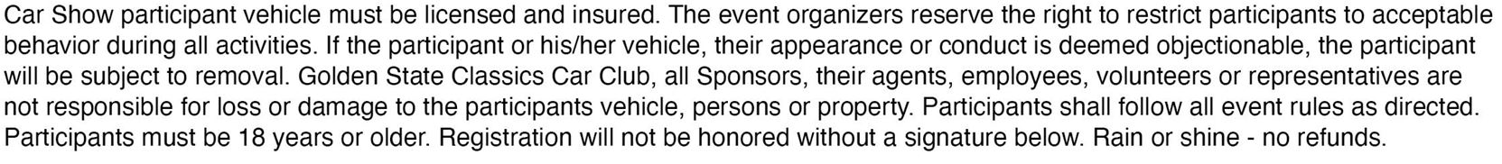

_____________________________________________________ __________________
Signature Date

